Macintosh HD:Users:epeters:Desktop:LOGOS:SEDCOR Brand Refresh:Horizontal:CMYK:SEDCOR_horiz_cmyk.pdfAug. 27, 2018

**President**

Chad Freeman

**2018-2019**

**Executive Counci**l

**Chair**

Mark Hoyt

Sherman Sherman

Johnnie & Hoyt, LLP

**Secretary/Treasurer**

**Chair Elect**

Daryl Knox

The Aldrich Group

**Past Chair**

Rich Duncan

Rich Duncan Construction

**Members at Larg**e

Kevin Cameron

Marion County

Commissioner

Michael Fowler

Cabinet Door Service

Lesa Goff

Wells Fargo Bank

Nathan Levin

N. Levin Industrial Real Estate

Steve Powers

City of Salem

Steve VanArsdale

Garmin AT, Inc.

**\_\_\_\_\_\_\_\_\_\_\_\_\_\_\_\_\_\_\_\_\_\_\_\_**

626 High St. NE

Suite 200

Salem, Or. 97301

503-588-6225

[www.sedcor.com](http://www.sedcor.com)

Brent Dehart

465 Commercial St. NE, Suite 100

Salem, Or. 97301

Dear Brent,

Thank you for the opportunity to work with you and the Mid-Valley Air Service Steering Committee on your quest to bring a commercial airline service to the Salem Airport, McNary Field.

Local connections to a global marketplace are a big piece of what we do at SEDCOR. Helping local companies like Garmin, Kettle Foods, Norpac, and others sell to markets far outside Oregon as well as the work we do with companies interested in moving to Oregon, we see air service as an essential part of our connectivity.

Whether a firm is currently located in the region or is planning to locate, transportation is vital to a company’s success. They want to be able to travel to and from locations quickly. Bringing a commercial airline service to the Salem would allow company employees to save time and money commuting to Portland.

A commercial airline would assist in reducing the traffic on Interstate 5. Many people living in or near Salem have shared their frustrations about the amount of time it takes to drive to Portland International Airport.

Along with Travel Salem and the Salem Area Chamber of Commerce, SEDCOR lends its support to the Mid-Valley Air Service Steering Committee to bring a major carrier to the Salem Airport, McNary Field.

Please feel free to contact me if I can answer any questions or be of further assistance.

Sincerely,

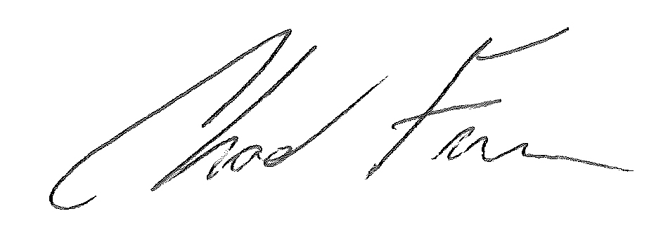

Chad Freeman

President